Wind speed variation with the distance (Related to Babak Bahrani tree burning experiments)

In this experiment, the initial velocities at the fans are 5.36 m/s (idle wind), 11.17 m/s (medium wind), and 17.88 m/s (high wind). X distance is 7.32 m.

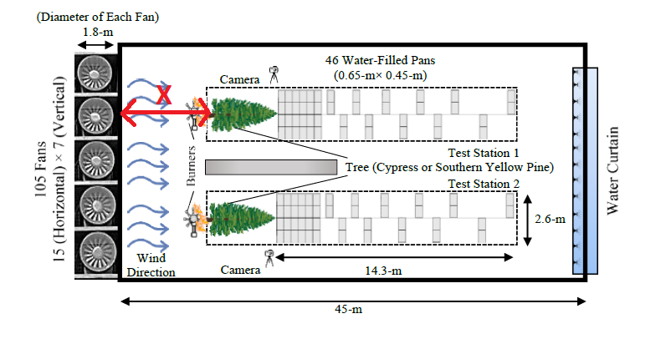

Similar to that, three simulations were completed for given initial wind speeds to find the wind speed at the tree base. The set up is as follows.

|  |  |
| --- | --- |
|  |  |

|  |  |
| --- | --- |
| Inlet velocity m/s (at z=-7.3 m) | Velocity at tree base m/s (at z=0 m) |
| 5.36 | 3.85 |
| 11.17 | 8.19 |
| 17.88 | 13.16 |

|  |  |
| --- | --- |
| Method 1 | Method 2 |
|  |  |

|  |
| --- |
|  |

|  |  |  |  |  |  |
| --- | --- | --- | --- | --- | --- |
|  | **Average wind velocity (m/s) at the back of the fireline** | | | | |
| **Location** | **FFDI 100** | **FFDI 80** | **FFDI 70** | **FFDI 60** | **FFDI 50** |
| Top of the crown | 13.43 | 11.31 | 10.33 | 9.19 | 8.56 |
| Bottom of the crown | 17.19 | 14.51 | 11.44 | 7.44 | 6.65 |
| Top of the understorey | 4.03 | 3.03 | 2.47 | 1.73 | 1.72 |
| Average velocity (1.5 m to 39.75 m) | 10.377 | 8.88 | 7.546 | 5.874 | 5.48 |

Using the trend line equations of Method 1,

|  |  |  |  |  |  |
| --- | --- | --- | --- | --- | --- |
| **Similar**  **Vegetation** | **Reference generation rate (pcs/MW/s)** | **Wind speed**  **(m/s)** | **Number of firebrands** | **Generation ratio to 2 m/s wind** | **Generation rate (pcs/MW/s)** |
| Loblolly Pine  Pitch Pine | 4.18  (at 2 m/s wind for Pitch Pine) | 2 | 298 | (298/298) =1.00 | 4.18🞨1.00=4.18 |
| 5.54 | 457 | (457/298) =1.53 | 4.18🞨1.53=6.40 |
| 8.93 | 514 | (514/298) =1.73 | 4.18🞨1.73=7.23 |
| 10.49 | 386 | (386/298) =1.30 | 4.18🞨1.30=5.43 |

Using the trend line equations of Method 2,

|  |  |  |  |  |  |
| --- | --- | --- | --- | --- | --- |
| **Similar**  **Vegetation** | **Reference generation rate (pcs/MW/s)** | **Wind speed**  **(m/s)** | **Number of firebrands** | **Generation ratio to 2 m/s wind** | **Generation rate (pcs/MW/s)** |
| Loblolly Pine  Pitch Pine | 4.18  (at 2 m/s wind for Pitch Pine) | 2 | 298 | (298/298) =1.00 | 4.18🞨1.00=4.18 |
| 5.48 | 454 | (454/298) =1.52 | 4.18🞨1.52=6.35 |
| 8.88 | 575 | (575/298) =1.92 | 4.18🞨1.92=8.03 |
| 10.38 | 575 | (575/298) =1.92 | 4.18🞨1.92=8.03 |

**Decided to proceed with Method 2

Radiative heat flux

Cases: For FFDI 100, 80, 50.

1. Calculated radiative heat flux by the algorithm
2. Simulation radiative heat flux when the distance between the firefront-forest edge = 5 m
3. Simulation radiative heat flux when the distance between the firefront-forest edge = 10 m

|  |
| --- |
|  |
|  |
|  |